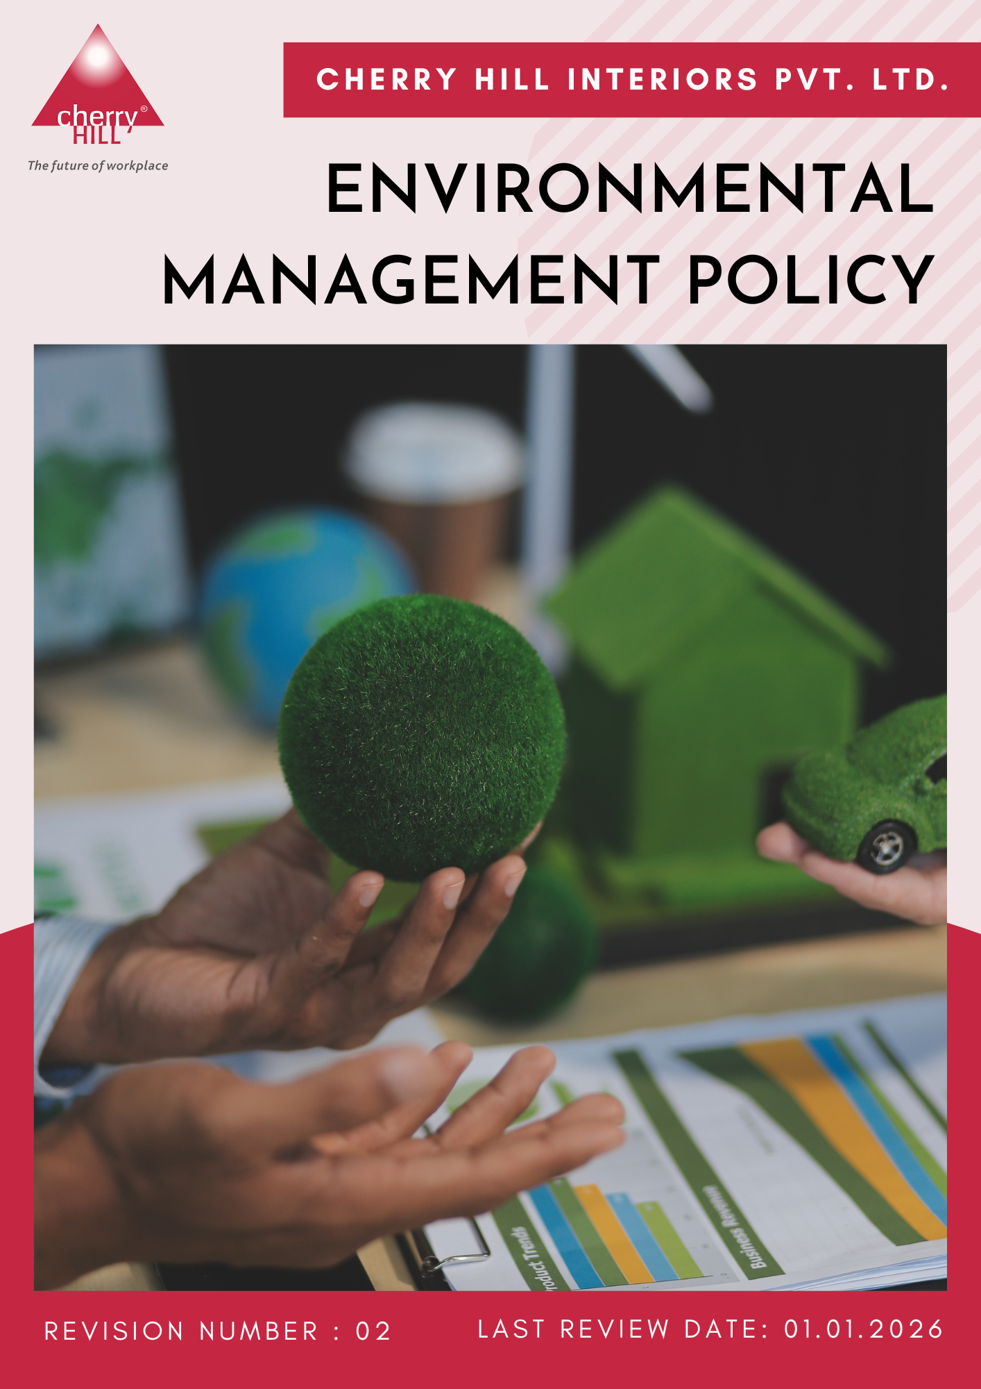

Contents
Preface 3
Scope 3
Policy Declaration 4
Key Action Areas 4
Qualitative Objectives 4
Targets based on our action areas 6
Responsibilities 7
Monitoring, Reporting and Transperancy 7
Alignment with SDGs 8
Review Mechanism 9
Employee Acknowledgement Form 10

Preface
Cherry Hill Interiors Pvt. Ltd. is a leading pan-India player in occupancy services, specializing in corporate office interiors, hospitals, and hotels. As a member of the U.S. Green Building Council (USGBC) and the Indian Green Building Council (IGBC), and holding ISO 9001:2015, 14001:2015, and 18001:2007 certifications, we are committed to embedding sustainability into our business practices. Our approach integrates environmental stewardship, resource conservation, pollution control, and responsible material usage to minimize our ecological footprint. We strive for continuous improvement in environmental performance through innovation, responsible sourcing, and engagement with stakeholders to promote sustainable interiors.
Scope
This policy applies to all business operations, including office spaces, project sites, supply chains, and interactions with stakeholders. It extends to employees, contractors, suppliers, and partners engaged in our business activities.
Sr. No. |  | Locations | Address
1. | Cherry Hill Interiors Pvt. Ltd. (CHIPL) | Delhi (Head Quarter) | Y-33, Okhla Industrial Area, phase-II, New Delhi, India - 110020.
2. |  | Bengaluru (Branch Office) | First floor, no 1, 14th a Main, Hall 2nd Stage, Bangaluru, Karnataka, India - 560008
3. |  | Chennai (Branch Office) | GN Chetty Road, Anmol Palani, 88, T Nagar, Chennai, Tamil Nadu, India - 600017
4. |  | Pune  (Branch Office) | Liberty phase-2, Plot no. 323, Flat no.1, North Main Road, Koregaon Park, Pune, Maharashtra, India - 411001
5. |  | Hyderabad (Branch Office) | Third floor, Sreshta Marvel, Sy no 136, Gachibowli Konadpur Main Road, Gachibowli, Hyderabad, Telangana, India - 500032
6. |  | Factory | Plot no. 81-a, sector-5, IMT Manesar, Gurugram, Haryana, India - 122050

NOTE: The Ahmedabad, Kolkata, and Sri Lanka sites are not operational, and less than 1% of employees are from this location out of the total.
Policy Declaration
Cherry Hill Interiors Pvt. Ltd. integrates environmental responsibility into its operations by reducing its carbon footprint, optimizing resource use, and ensuring compliance with all relevant regulations. With 2022 as the baseline year, sustainability improvements are driven through innovation, responsible design, and collaboration with industry leaders to achieve our long-term environmental targets.
Key Action Areas
- Achieving Energy Efficiency and Lowering GHG Emissions: Energy consumption, renewable energy adoption, and emissions management.
- Advancing Water Conservation and Reuse: Water consumption, conservation measures, and water recycling practices.
- Reducing Air Pollution and Enhancing Air Quality: Air emission controls and indoor air quality management.
- Advancing Responsible Material Use and Waste Management: Sustainable material sourcing, resource efficiency, and waste handling.
- Protecting Biodiversity and Green Spaces: Green infrastructure, landscaping, and ecological conservation initiatives.
- Ensuring Customer Health and Safety: Service and workplace measures supporting occupant safety.
- Driving Environmental Advocacy and Awareness: Sustainability training, awareness programs, and stakeholder engagement activities.
Qualitative Objectives
- Achieving Energy Efficiency and Lowering GHG Emissions
- To achieve greater energy efficiency and reduce greenhouse gas emissions, by integration of sustainable practices across operations such as expanded use of renewable energy sources, automation, and implementation of energy-efficient technologies.

- Advancing Water Conservation and Reuse
- To achieve efficient water management, by focusing on optimizing usage and increasing recycling efforts. To integrate water-efficient technologies across operations, and promote responsible water use throughout our supply chain.

- Reducing Air Pollution and Enhancing Air Quality
- To achieve a cleaner environment, by adoption of low-emission materials, improved ventilation systems, and implementation of advanced dust control mechanisms.

- Advancing Responsible Material Use and Waste Management
- To achieve responsible material use and minimize waste by prioritizing sustainable sourcing, improved waste segregation procedures, and enhanced circularity through collaborations with recycling firms.
- Strengthening of waste management protocols to ensure responsible disposal and landfill diversion.

- Protecting Biodiversity and Green Spaces
- To achieve biodiversity conservation by increasing native tree plantations and incorporating eco-friendly landscaping.
- To focus on collaboration with environmental organizations that support habitat preservation and ecological restoration.

- Ensuring Customer Health and Safety
- To maintain the highest standards of customer health and safety through responsible design practices, safe materials, and effective project management.
- To create interior spaces that support occupant wellbeing through responsible material selection, ergonomic design, and adherence to health and safety best practices.

- Driving Environmental Advocacy and Awareness
- To achieve greater sustainability awareness by engaging in industry collaborations, conducting employee training sessions, and participating in public advocacy initiatives.
- Embedding environmental responsibility into corporate culture and stakeholder communications.
Targets based on our action areas
- Achieving Energy Efficiency and Lowering GHG Emissions
- To decrease the total energy consumption intensity by 10% and lower the GHG emissions intensity by 5% through operational efficiencies and renewable energy integration in the park till year 2028.
- To reduce Scope 3 emissions intensity by 5% till year 2028.

- Advancing Water Conservation and Reuse
- To reduce water consumption intensity by 20% per square foot constructed by optimizing operations and using water-efficient fixtures by year 2028.
- To increase water recycling and reuse intensity by 20% per project site where applicable, by integrating closed-loop systems and greywater reuse technologies by year 2028.

- Reducing Air Pollution and Enhancing Air Quality
- To maintain 100% compliance with national air quality standards by conducting regular monitoring in order to ensure that emissions remain within regulatory limits while promoting healthier workspaces till year 2028 and thereafter.
- Adopt the utilization of 50% materials in interiors with low-VOC to improve indoor air quality by year 2028.
- To reduce airborne pollutant emissions intensity by 10% per construction project through dust control mechanisms and low-emission materials by year 2028.

- Advancing Responsible Material Use and Waste Management
- To ensure implementation of structured waste segregation across 100% of project sites by tracking till year 2028.
- To utilize 10% of materials from recycled or sustainable sources by year 2028
- To reduce hazardous waste generation intensity by 15% through recycling and recovery till year 2028.

- Protecting Biodiversity and Green Spaces
- To achieve the target of planting 100 trees annually in project-associated areas and dedicating 5% of our outdoor office spaces to green landscaping till year 2028.

- Ensuring Customer Health and Safety
- Maintain zero customer-related health and safety incidents across all project sites and completed projects by year 2028.
- To ensure 80% of furnishings are free from harmful chemicals by year 2028 in order to maintain health, safety of customers and quality aspects of project delivery.

- Driving Environmental Advocacy and Awareness
- Conduct Sustainability training sessions twice in one year for employees and stakeholders.
- Participate in a 2 sustainability forums till year 2028.
- Develop one industry-wide initiative by promoting sustainable design and responsible resource use till year 2028.

Responsibilities
- The Environmental Manager oversees implementation and compliance with this policy.
- Project Managers and Designers ensure sustainability principles are integrated into all projects.
- Employees and Contractors adhere to environmental standards and contribute to resource efficiency.
Monitoring, Reporting and Transperancy
Cherry Hill Interiors is committed to monitoring its environmental performance across key focus areas, including energy efficiency, GHG emissions, water conservation, air quality, responsible material use, waste management, biodiversity, customer health and safety, and environmental awareness. Relevant Key Performance Indicators (KPIs) are established and tracked to assess progress against the company's sustainability objectives and targets.
Performance is reviewed periodically by management to support informed decision-making and continuous improvement. Regular assessments are conducted to evaluate achievements, identify gaps, and implement corrective actions where necessary. Progress and key outcomes are communicated to relevant stakeholders, as appropriate, to promote transparency and accountability. All monitoring and reporting activities are conducted in alignment with applicable legal requirements, industry best practices, and recognized sustainability standards.

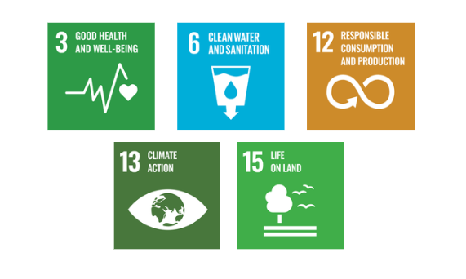
Alignment with SDGs

Review Mechanism
- The Environmental Management policy is reviewed once after every two years or as required by the Environmental Manager to ensure alignment with regulatory changes, technological advancements, and industry best practices.
- Regular audits and assessments are conducted to measure performance against targets.
- Feedback from stakeholders are incorporated to enhance environmental initiatives.

Last Review Date | : 01.01.2026
Next Review Date | : 01.01.2028
Approved By | :

Employee Acknowledgement Form
I acknowledge that I have received, read, and understood the Environmental Management Policy of Cherry Hill Interiors Pvt. Ltd. I agree to comply with the principles outlined in this policy, including responsible resource use, waste reduction, energy efficiency, and adherence to environmental regulations.
I understand my role in supporting the company’s sustainability commitments and will take necessary actions to minimize environmental impact in my daily work. I also acknowledge my responsibility to report any environmental concerns or non-compliance issues through the appropriate channels.
By signing this acknowledgment, I confirm my commitment to contributing to Cherry Hill Interiors’ environmental objectives and fostering a culture of sustainability.

Employee Name  Employee ID  Date  Signature | : _______________________________  : _______________________________ :________________________________  : _______________________________

